Black

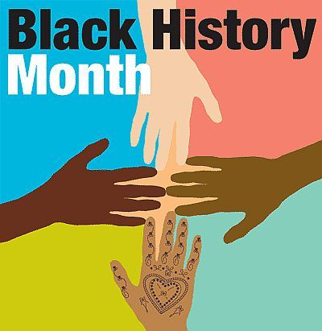

*Black History Month*

*Resources*

*at the NES Library*

Image: http://blogs.oregonstate.edu

**Print Resources**

**Biographies** can be found in the Library under the call number **92 and the first three letters of the last name of the person you are researching.**

Your public Library can help! Books may be found at your library or can be borrowed from other libraries in the area and sent to your hometown library for pick up.

Search the [catalog](http://newbury.mvlc.org/eg/opac/home?locg=55;) at <http://newbury.mvlc.org/eg/opac/home?locg=55>

**Online Resources**

[**Britannica Online** from the NES Library webpage](http://neslibrary.weebly.com/research-links.html)

<http://neslibrary.weebly.com/index.html>

Go to Research Links from the Library webpage to access Britannica. Search for your subject and open the article to find all of the Britannica features. Consider searching the Middle School edition too, the link can be found at the bottom of the Britannica page.

[**Biography in Contex**t](http://ic.galegroup.com/ic/bic1/?userGroupName=mlin_n_newbury) from the NES Library webpage

<http://neslibrary.weebly.com/index.html>

Go to Research Links from the Library webpage and scroll down to find Biography in Context. Search for your subject and open the full article. Under each article is a Reference tab where you will find more links to information about the person you are researching. ***This is an excellent resource for those hard to find biographies!***

[**Black History Month – Free Gale Resources**](http://www.gale.cengage.com/free_resources/bhm/bio/)

<http://www.gale.cengage.com/free_resources/bhm/bio/>

Similar to Biography in Context (listed above,) this website will provide you with brief overview articles.

[**Fact Monster – Black History Month**](http://www.factmonster.com/black-history-month/special-features.html)

<http://www.factmonster.com/black-history-month/special-features.html>

[**Internet Public Library**](http://www.ipl.org/)

<http://www.ipl.org/>

Search with this search engine for information you can trust from the web.

J. Brown 2/2013